Assignment 3.1
Hadoop 2.x has the following two Major Components:
1. HDFS (Hadoop Distributed File System)
2. YARN (Yet Another Resource Negotiator)

1. HDFS – Hadoop Distributed File System (Storage Component)
Hadoop File System was developed using distributed file system design. It is run on commodity hardware. Unlike other distributed systems, HDFS is highly faulttolerant and designed using low-cost hardware.
HDFS holds very large amount of data and provides easier access. To store such huge data, the files are stored across multiple machines. These files are stored in redundant fashion to rescue the system from possible data losses in case of failure. HDFS also makes applications available to parallel processing.
Features of HDFS :
1. It is suitable for the distributed storage and processing.
2. Hadoop provides a command interface to interact with HDFS.
3. The built-in servers of namenode and datanode help users to easily check the status of cluster.
4. Streaming access to file system data.
5. HDFS provides file permissions and authentication.
Namenode:
The namenode is the commodity hardware that contains the GNU/Linux operating system and the namenode software. It is a software that can be run on commodity hardware. The system having the namenode acts as the master server and it does the following tasks:
1. Manages the file system namespace.
2. Regulates client’s access to files.
3. It also executes file system operations such as renaming, closing, and opening files and directories.
Datanode :
The datanode is a commodity hardware having the GNU/Linux operating system and datanode software. For every node (Commodity hardware/System) in a cluster, there will be a datanode. These nodes manage the data storage of their system.
1. Datanodes perform read-write operations on the file systems, as per client request.
2. They also perform operations such as block creation, deletion, and replication according to the instructions of the namenode.
Block :
Generally the user data is stored in the files of HDFS. The file in a file system will be divided into one or more segments and/or stored in individual data nodes. These file segments are called as blocks. In other words, the minimum amount of data that HDFS can read or write is called a Block. The default block size is 64MB, but it can be increased as per the need to change in HDFS configuration
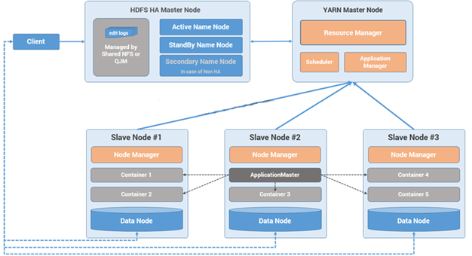

2.MapReduce 2.x Daemons (YARN)
In Hadoop 1.x Architecture Job Tracker daemon was carrying the responsibility of Job scheduling and Monitoring as well as was managing resource across the cluster. And Task Tracker daemon was executing map reduce tasks on the slave nodes. YARN has divided the responsibilities of Job Tracker to two processes Resource Manager and Application Master and instead of Task Tracker is using Node Manager daemon for map reduce task execution.

YARN has total three major components :
- Resource Manager
- Node Manager
- Application Master

1) Resource Manager

- This daemon process resides on the Master Node (not necessarily on Name Node of Hadoop)
- Responsible for,
  - Managing resources scheduling for different compute applications in an optimum way
  - Coordinating with two process on master node, Scheduler and Application Manager
Scheduler
- This daemon process resides on the Master Node (runs along with ResourceManager daemon )
- Responsible for,
  - Scheduling the job execution as per submission request received by Resource Manager
  - Allocating resources to applications submitted to the cluster
  - Coordinating with Application Manager daemon and keeping track of resources of running applications
Application Manager

- This daemon process resides on the Master Node (runs along with Resource Manager daemon )
- Responsible for,
  - Helping Scheduler daemon to keeps track of running application by coordination
  - Accepting job submissions from client
  - Negotiating first container for executing application specific task with suitable Application Master on slave node
2) Node Manager

- This daemon process resides on the slave nodes (runs along with DataNode daemon)
- Responsible for,
  - Managing and executing containers
  - Monitoring resource usage (i.e. usage of memory, cpu, network etc..) and reporting it back to Resource Manager daemon
  - Periodically sending heart-bits to Resource Manager for its health status update
3) Application Master

- This daemon process runs on the slave node (along with the NodeManager daemon)
- It is per application specific library works with NodeManager to execute the task
- The instance of this daemon is per application, which means in case of multiple jobs submitted on cluster, it may have more than one instances of ApplicationMaster on slave nodes
- Responsible for,
  - Negotiating suitable resource containers on slave node from ResourceManager
  - Working with one or multiple NodeManagers to monitor task execution on slave nodes
Container :

It is considered to be a small unit of resources (like cpu, memory, disk) belong to the SlaveNode
Scheduler process running along with Resource Manager daemon allocates the resources as a container
At the beginning of a job execution with YARN, container allows Application Master process to make a use of some resources on any slave node on the cluster
Then Application Master manages the application execution across other containers on slave nodes of a YARN cluster
